Graphana for logging and monitoring  
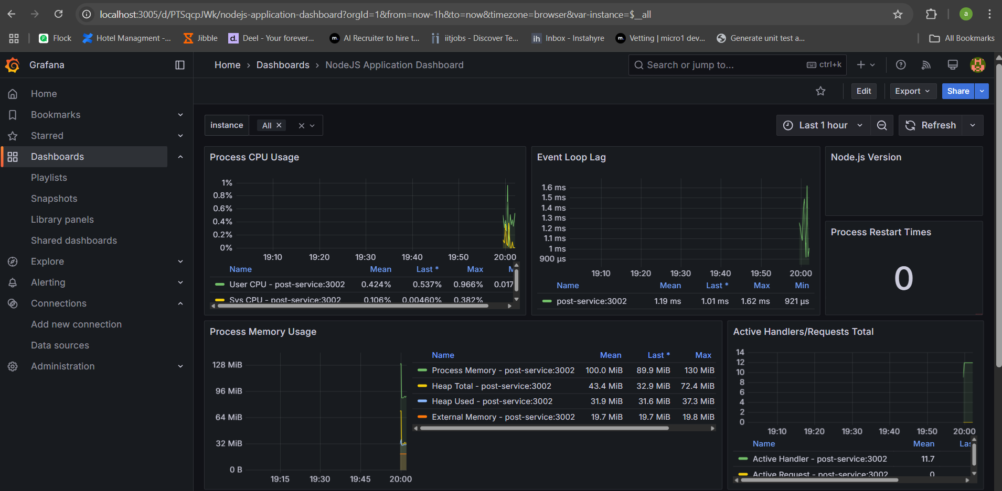

Consule Service discovery

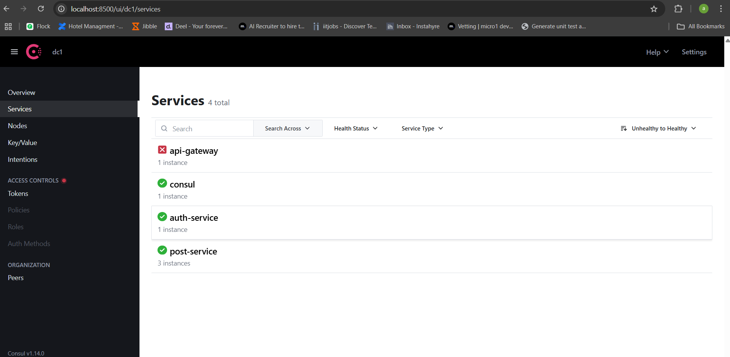  
  
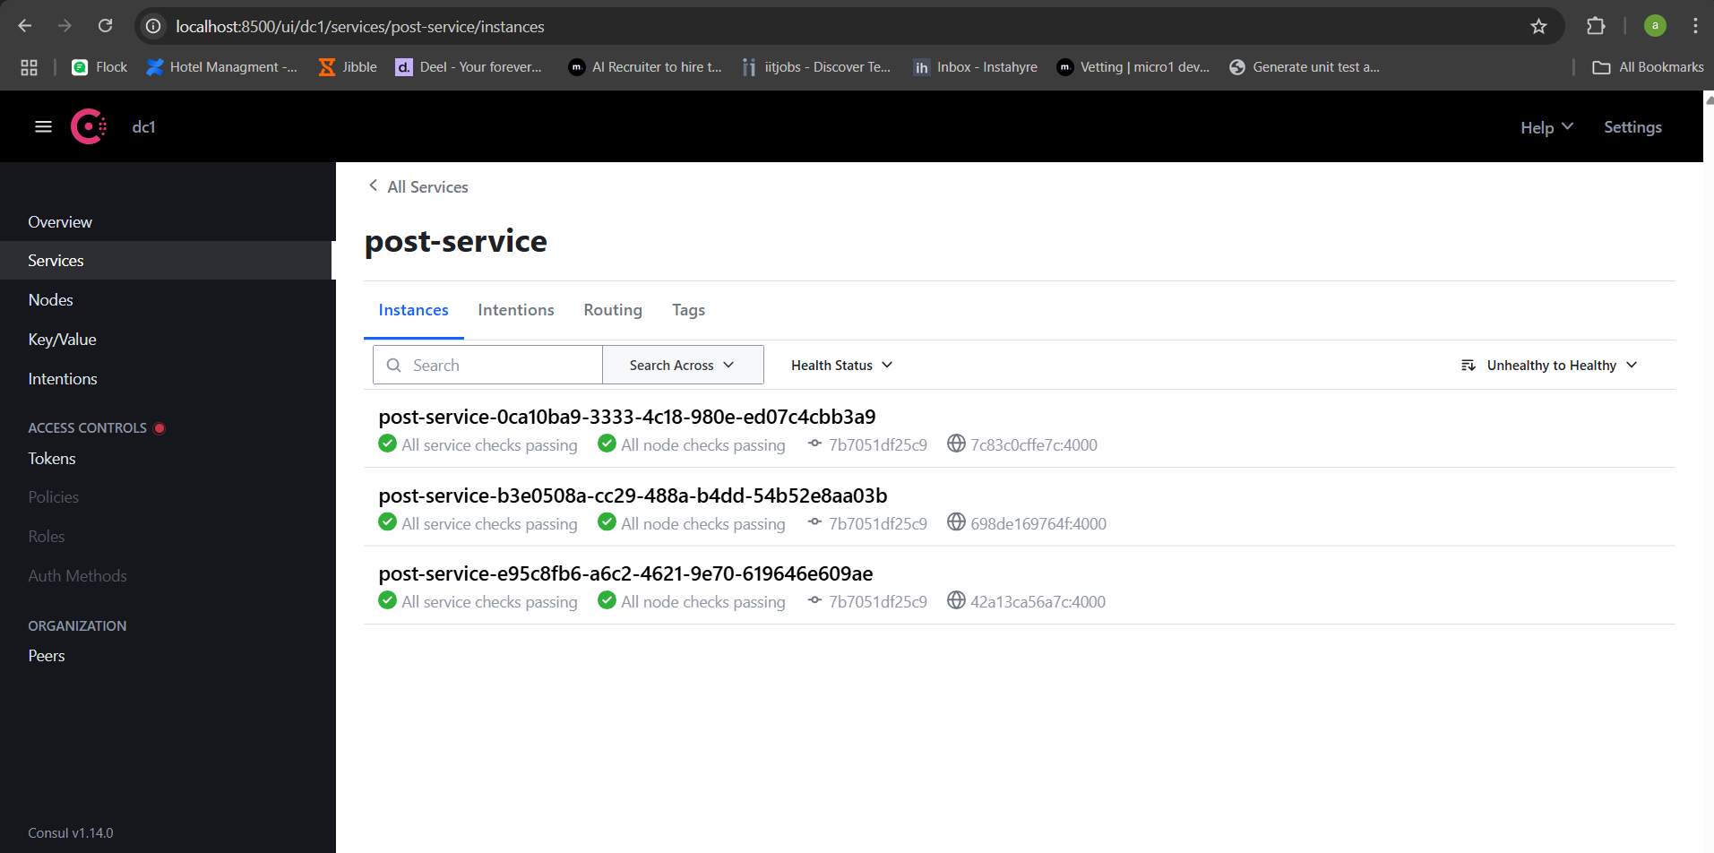

API gateway Swagger  
  
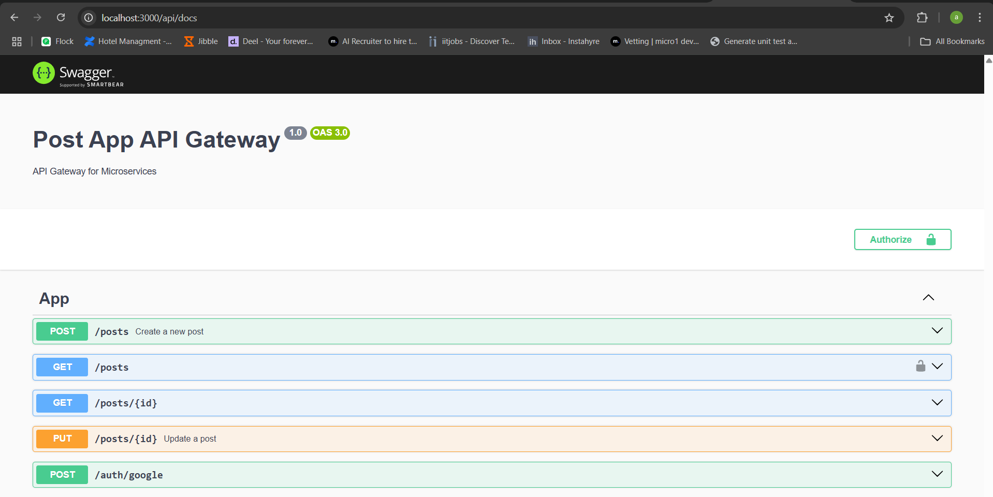

Load Balancer  
  
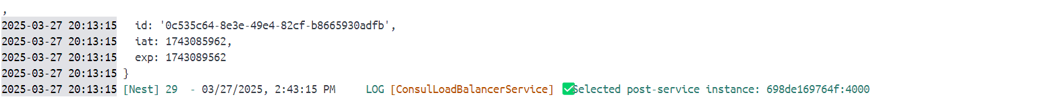  
dynamic service selection with consul

Redis cache implementation  
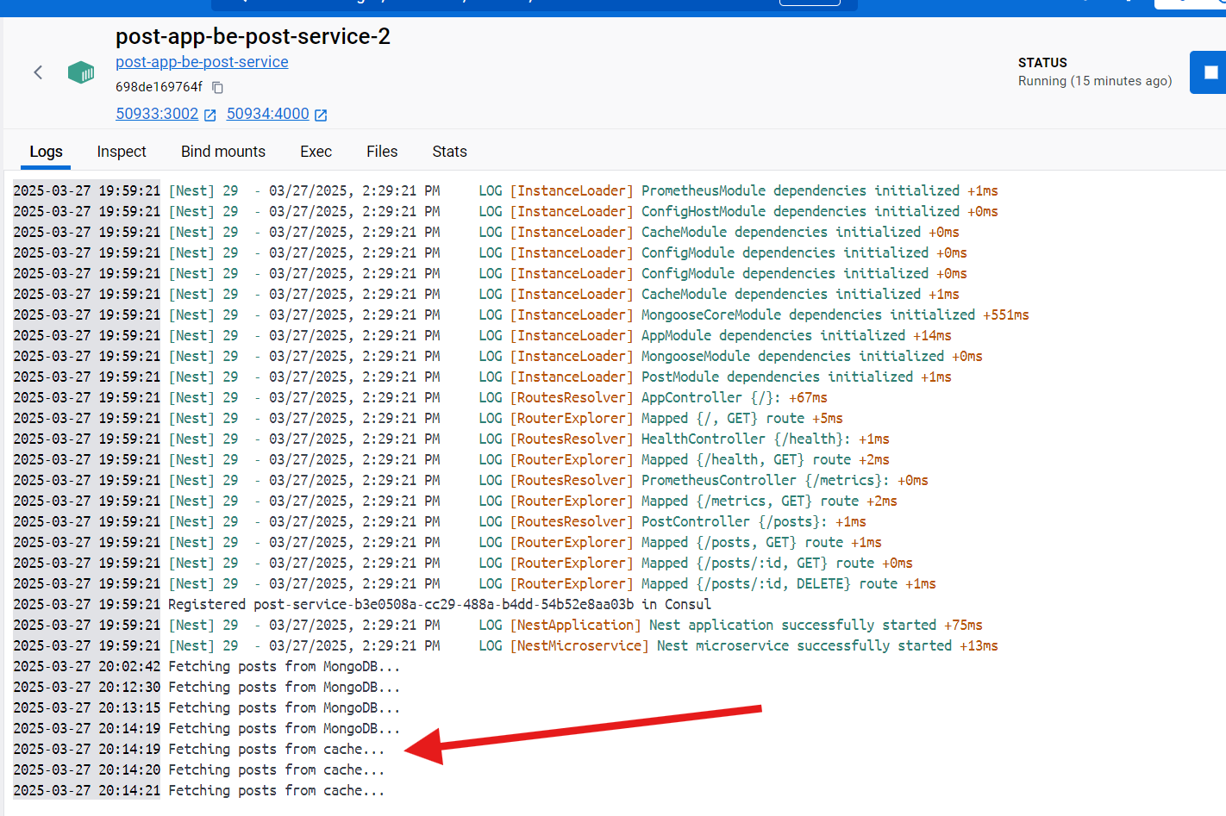

Throttle implementation to avoid DOS attack  
  
